

Programme Name: ________**BCS HONS**_______________________________________

Course Code: __**MATH 1023**________

Course Name: ________**Additional Mathematics**___________________________

**Assignment** / Lab Sheet / Project / Case Study No. _**1**__

Date of Submission: ______**7/31/2020**_____________

**Submitted By: Submitted To:**

Student Name**: Dipesh Tha Shrestha** Faculty Name**: SHANTA RAYAMJHI BASNET**

IUKL ID: **041902900028** Department**: LMS**

Semester**: Second Semester**

Intake**: September 2019**

Q.N. 1

a. Three numbers are in the ratio of 1:2:4. If 3 is added to the first and 8 is subtracted from the third then the new numbers will be in Arithmetic Progression. Find the numbers.

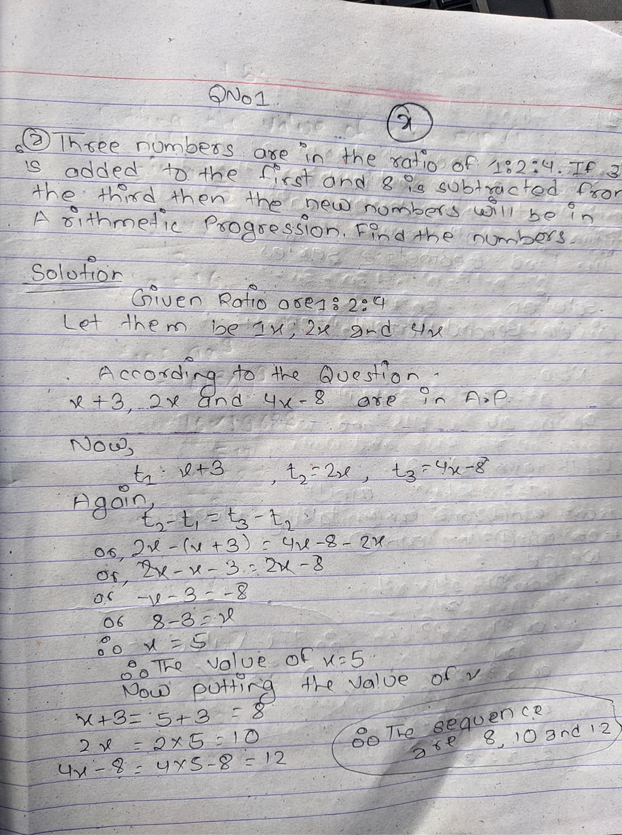

b. If 2nd and 5th term of a G.P. is 24 and 81 then find

1. First and common ratio
2. Find 10th term
3. Find geometric series.

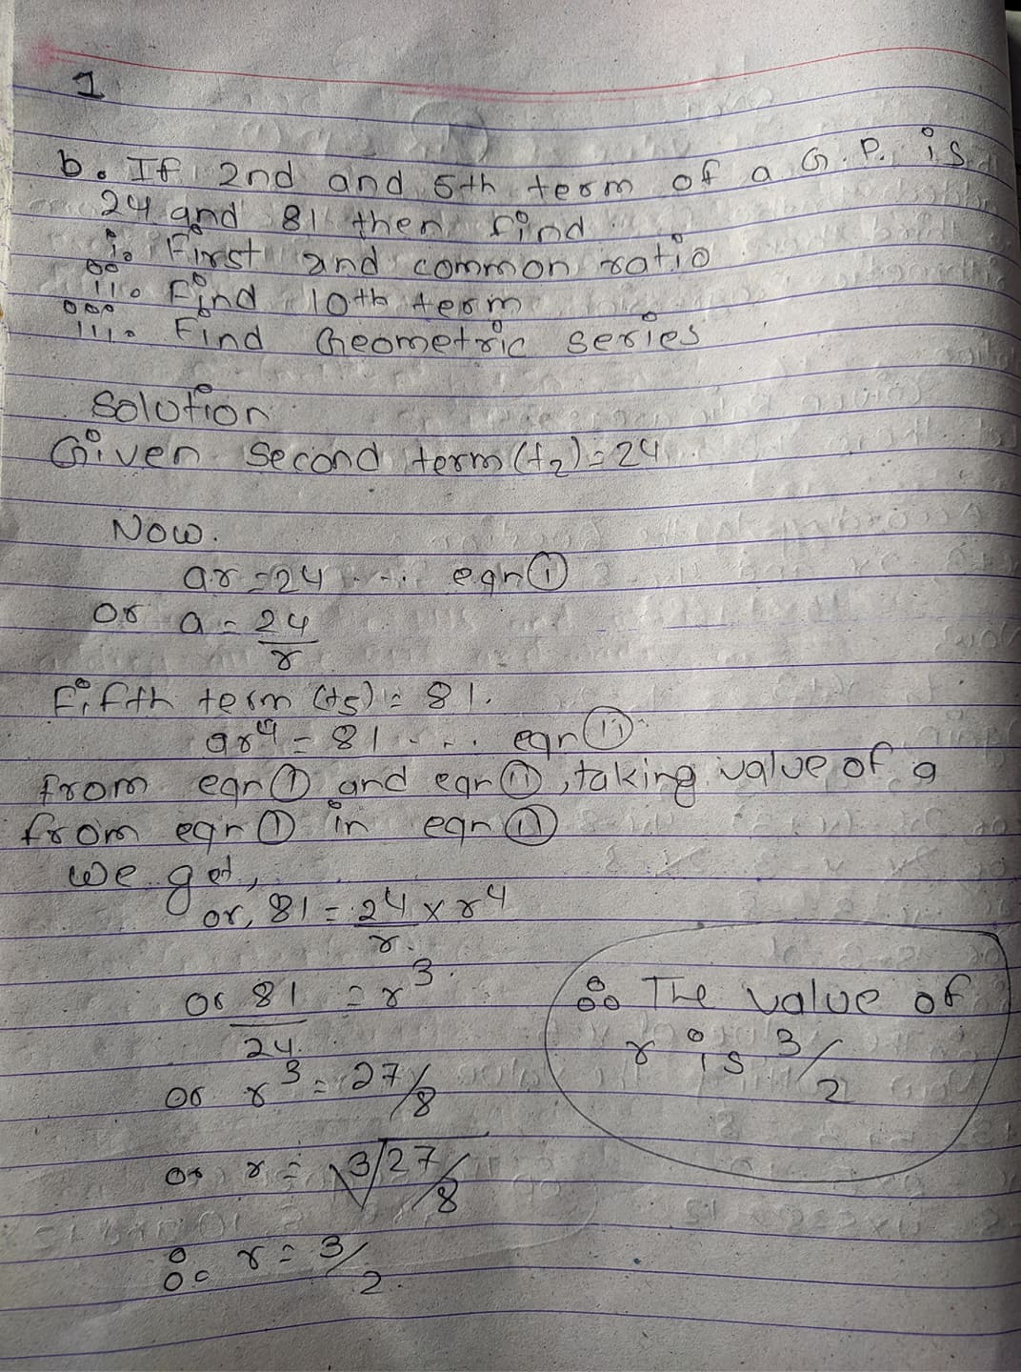

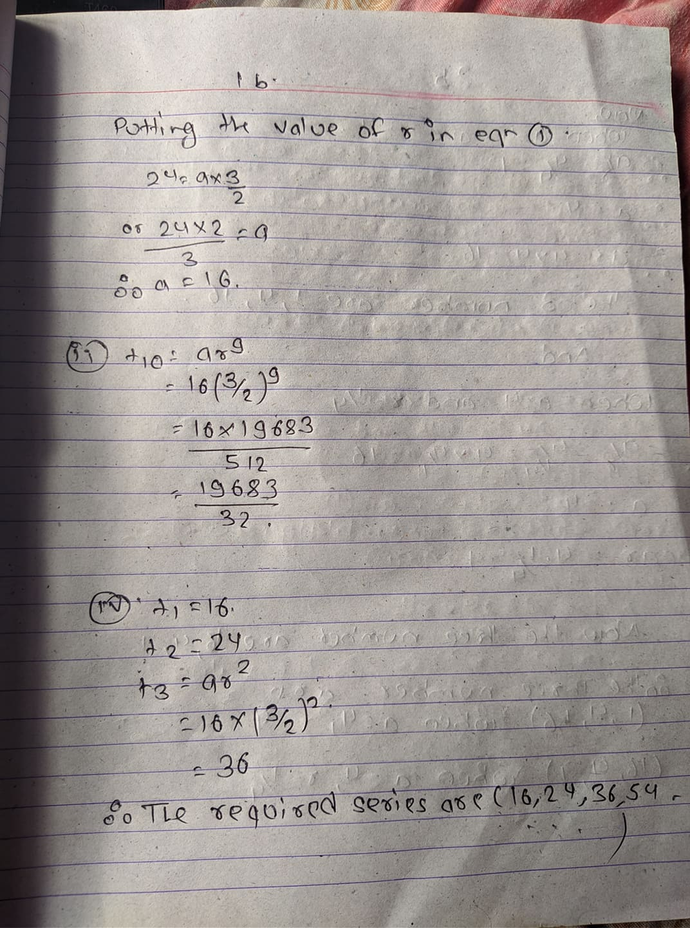

Q.N.2

a. In a G.P. the sum of three numbers is 21 and their product is 64 then finds them.

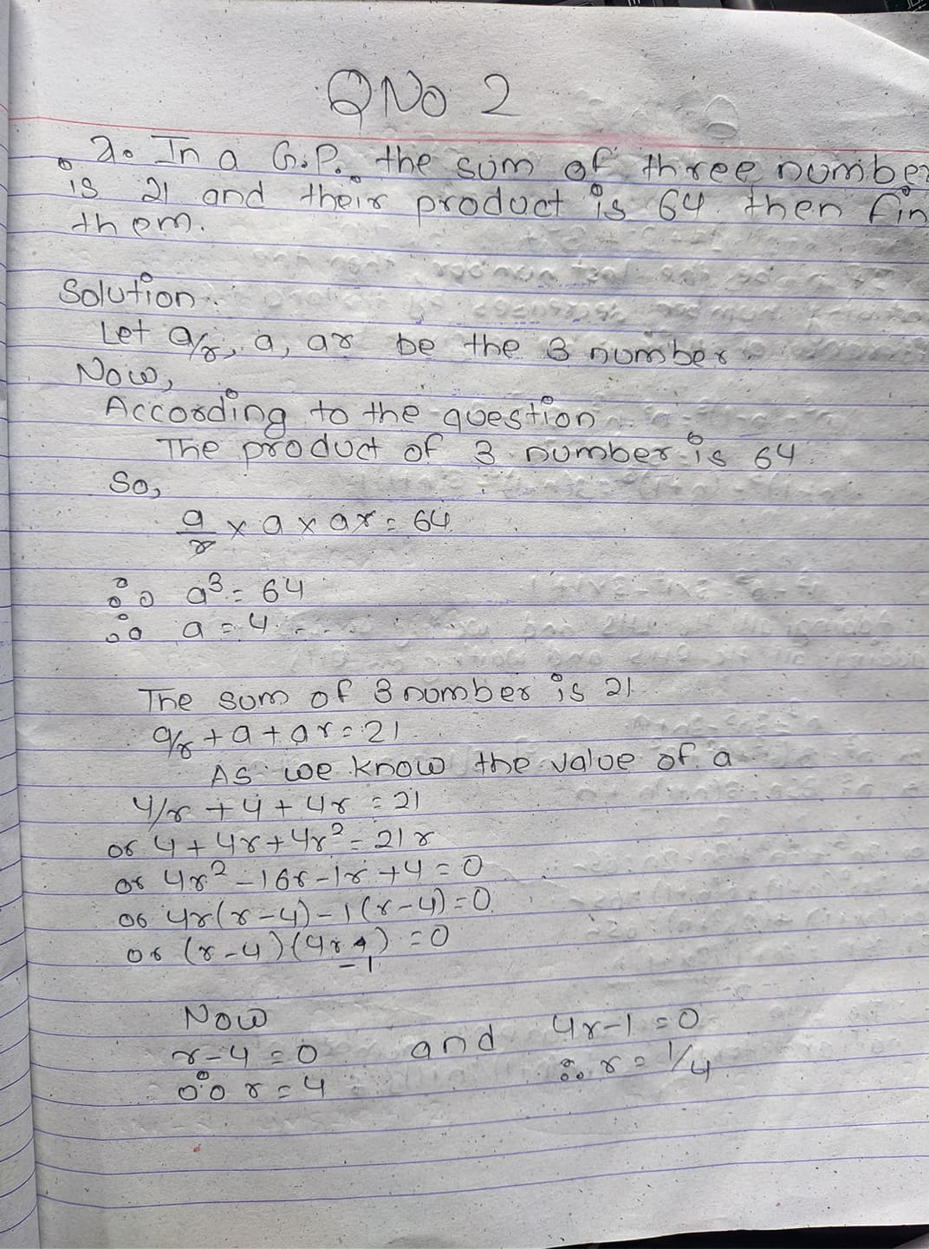

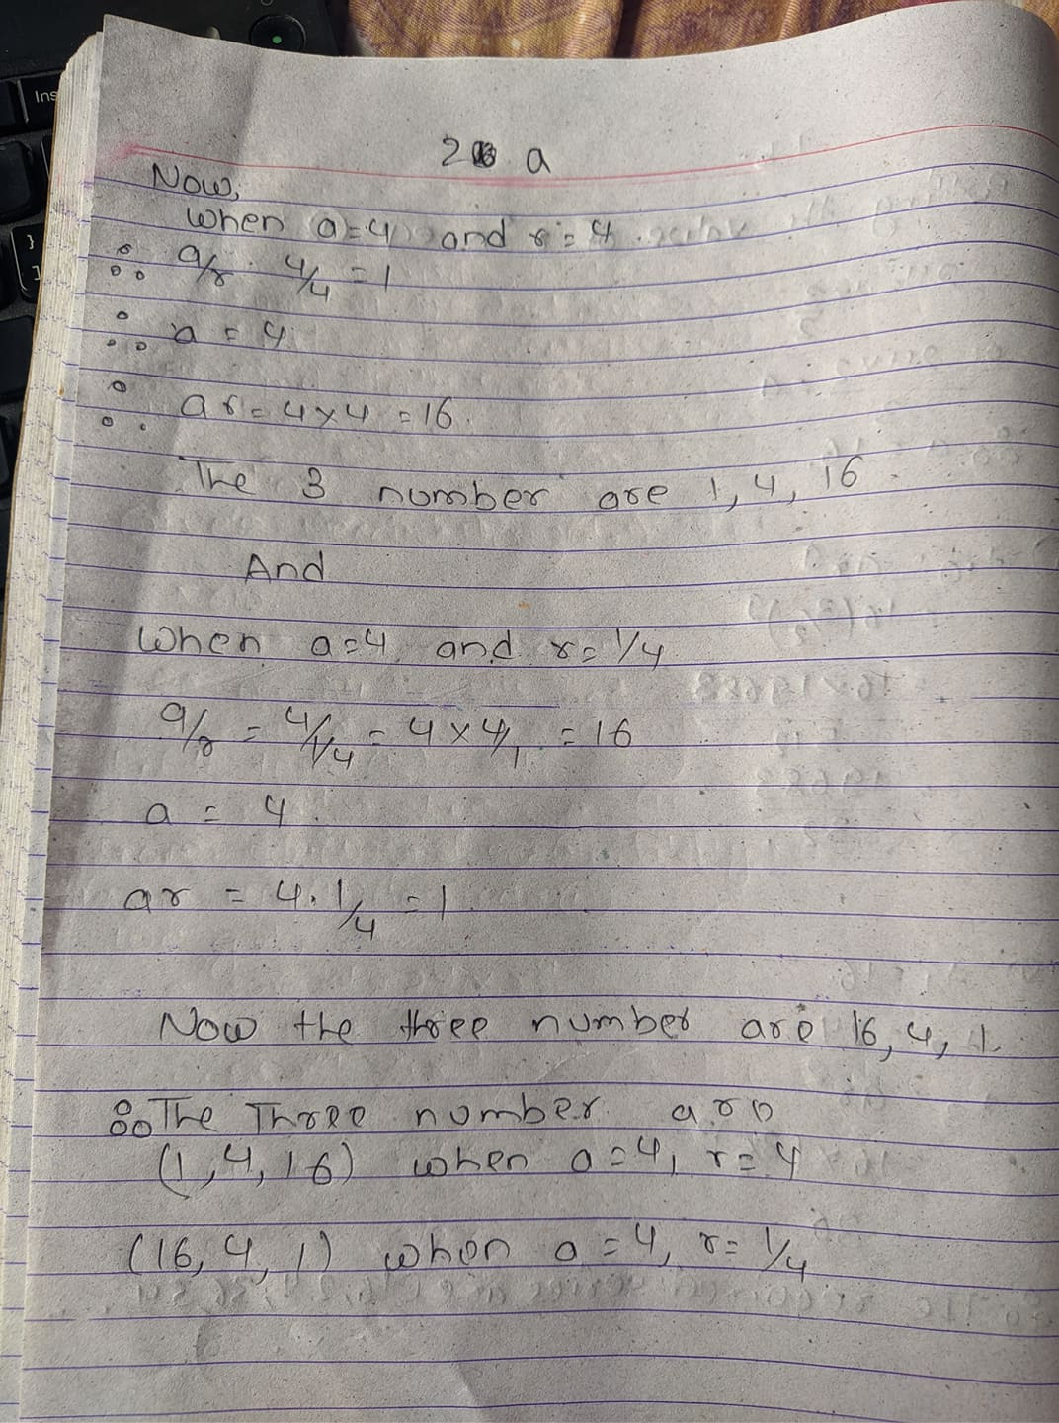

b. Find the sum of: 12 + 22 + 32+ … …+ n2

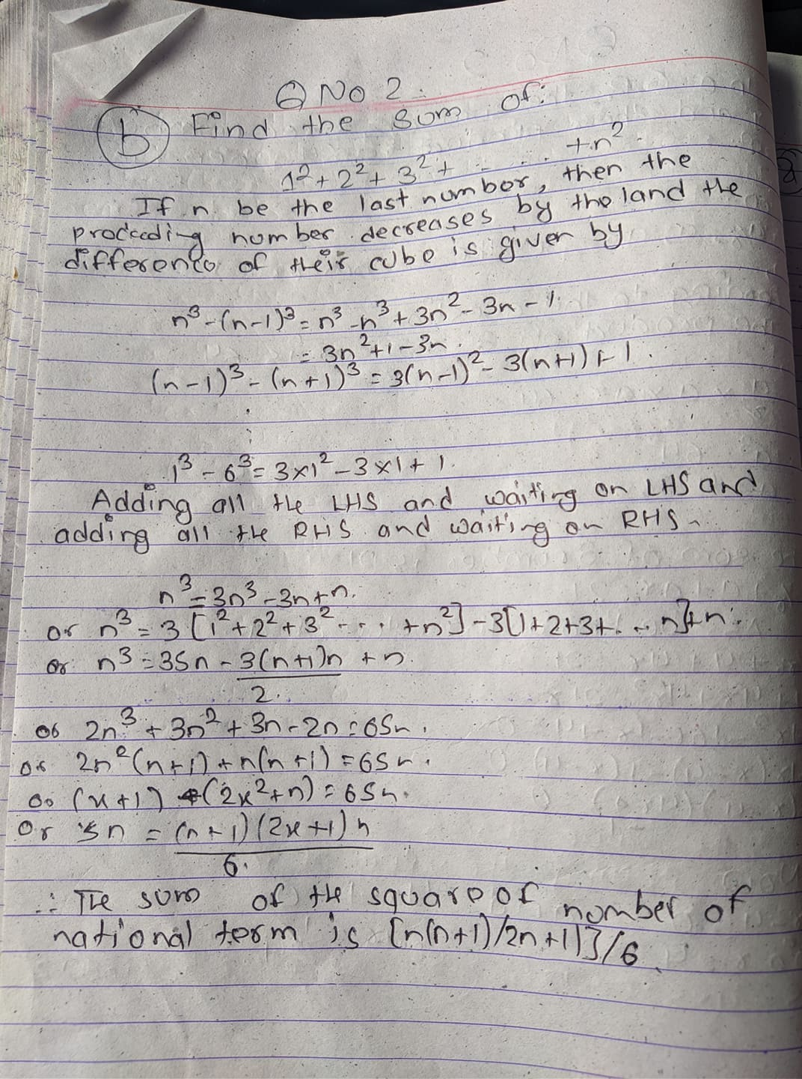

Q.N.3

a. Solve the given equation by using completion of square 2*x*2 + 4*x* − 4 = 0

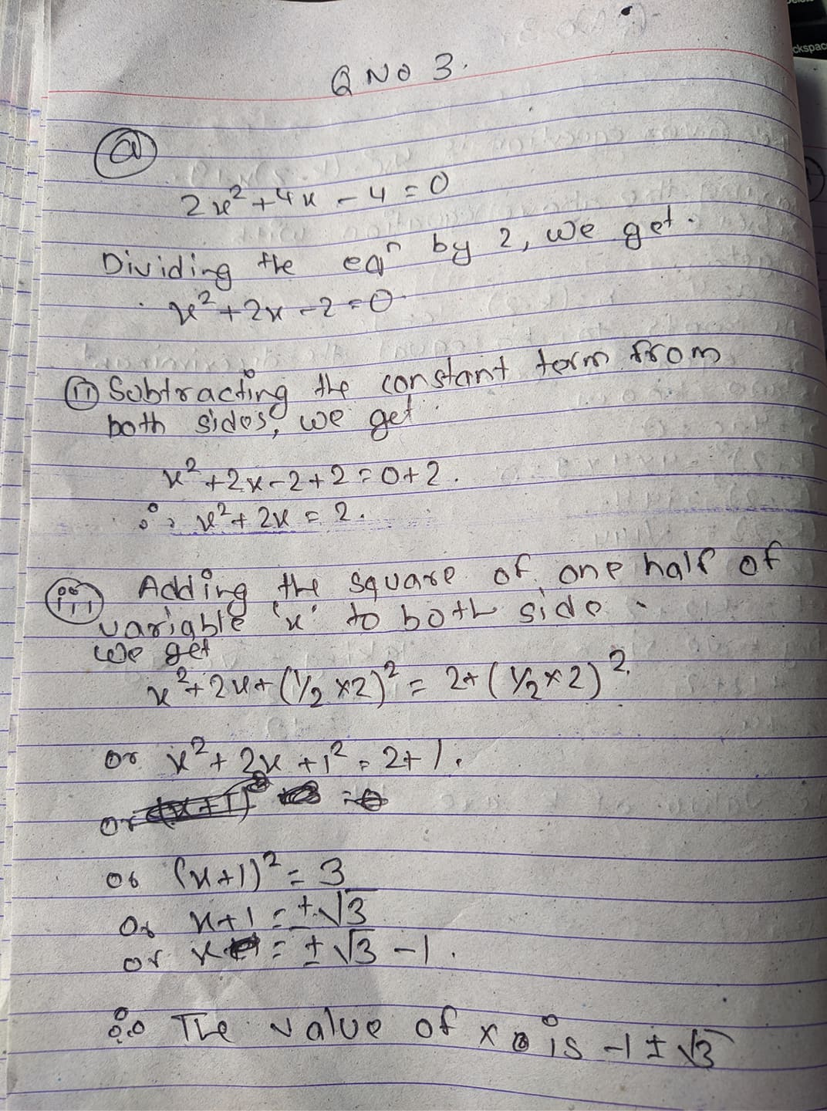

b. Find the value of k for which the root of the equation 4x2-(k-2)x+9=0 will have two equal roots

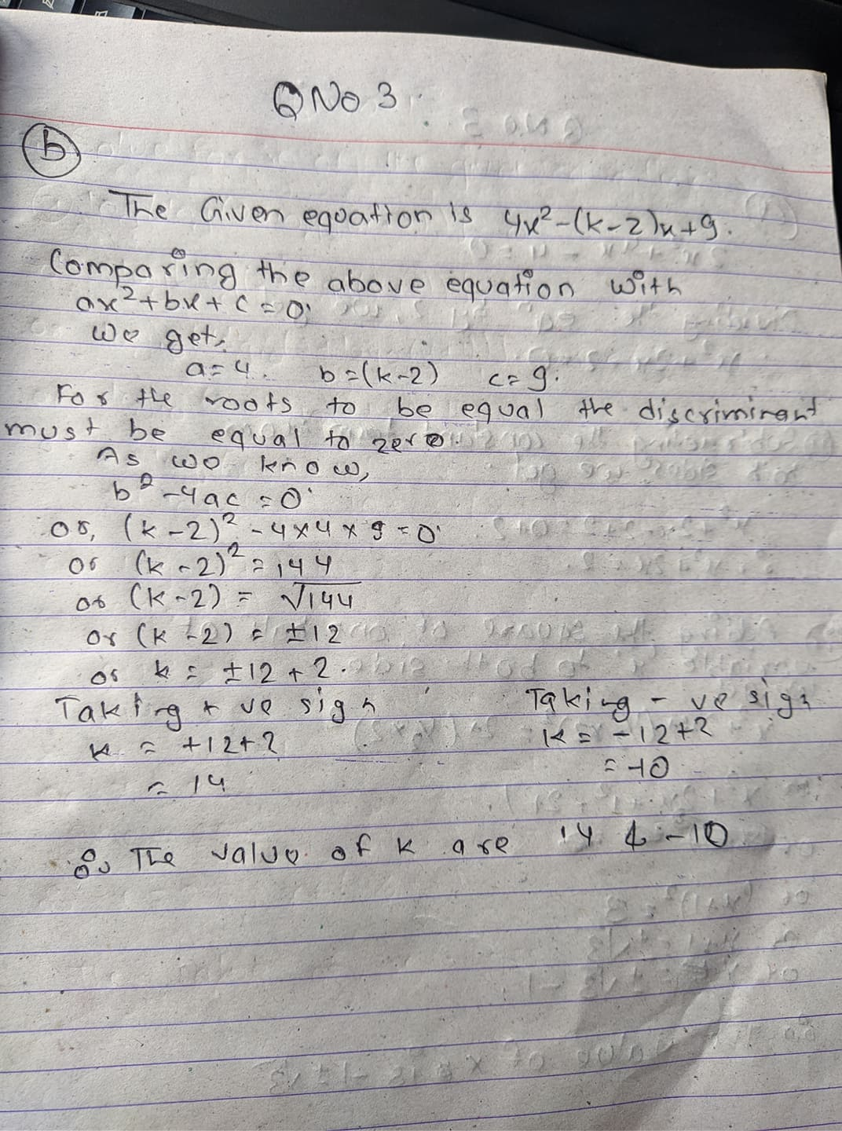

Q.N.4

Solve for x of the given the equation:

1. log [ log (2 + log2(x + 1)) ] = 0

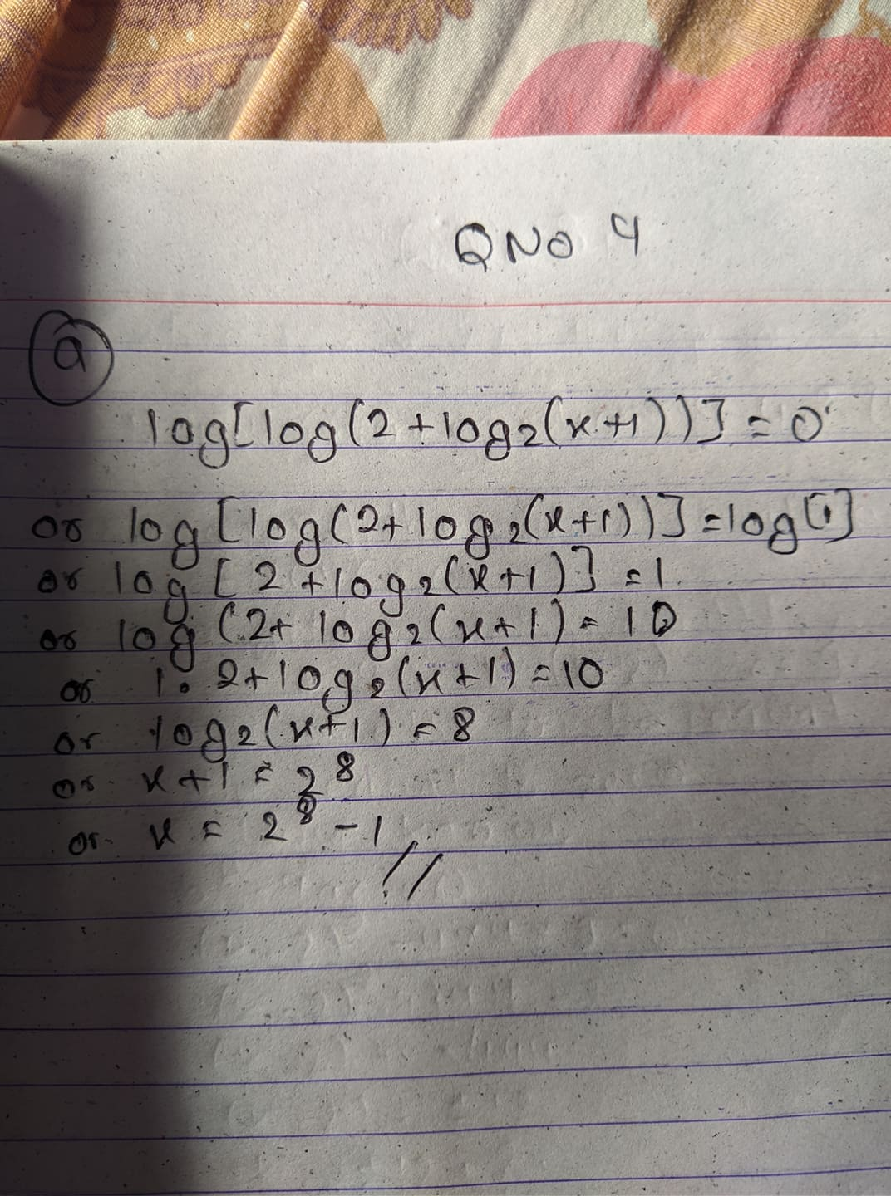

b. 103*x* – 2 = 13

